**Level-of-Detail**

Demonstrations of Level-of-Detail (LOD). In each case, an object is animated away from the camera. When the object is 4 units from the camera, it switches to another mesh. At 9 units away, it switches again to another mesh per the requirements of LOD.



Most scenes include an animated object with the texture map on the right. This object is not related to Level-of-Detail – it simply adds some variety to the tests.

**levelofdetail02.x3d**

Most of the scenes follow a similar pattern. The points of change in the level of detail as designated where the texture maps reads “Marker ONE” and “Marker TWO”. The middle object with a texture map that includes “Level of Detail” 1, 2 or 3 are animated in several steps:

In front of Marker ONE, the LOD mesh pauses, then moves behind Marker ONE and changes to mesh with “Level of Detail 2” (NOTE: this is not a texture map change but an entirely different object).

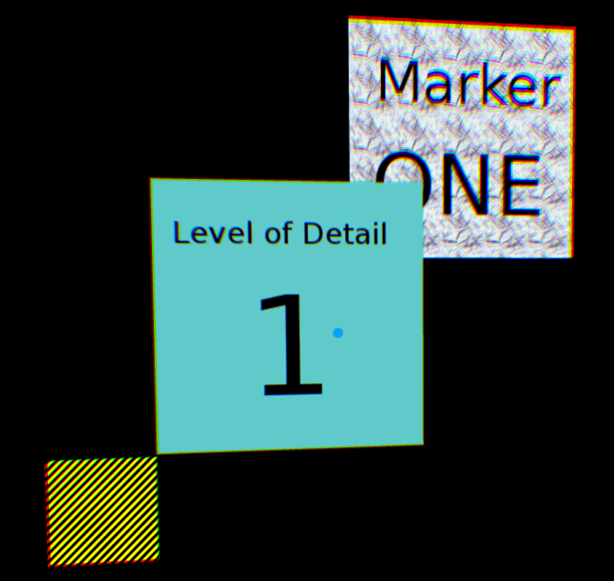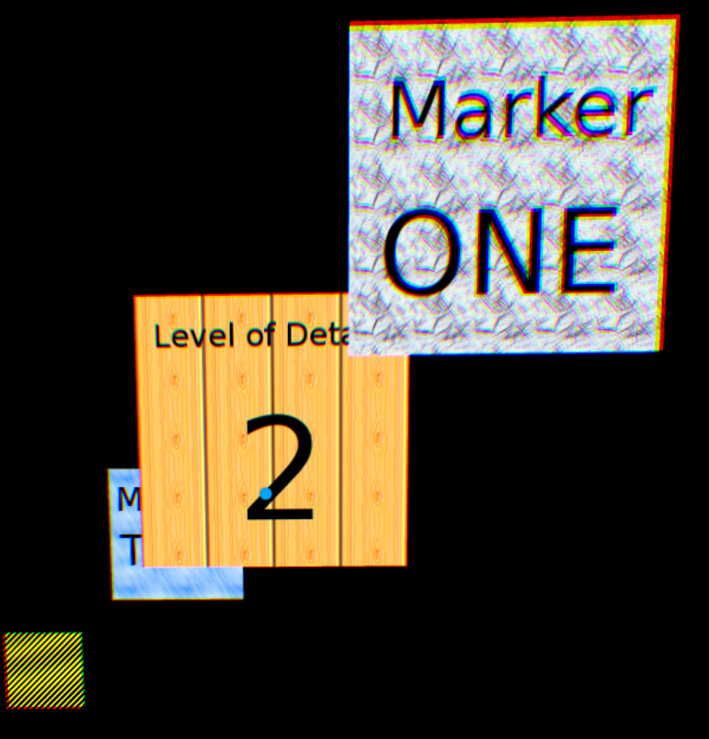

After pauses behind Marker ONE (4 units from the camera), it animates to just in front of Marker TWO. It pauses again, animates slowly behind Marker TWO (9 units from the camera), and changes to a third object mesh with a texture map that reads “Level of Detail 3” and then pauses again.

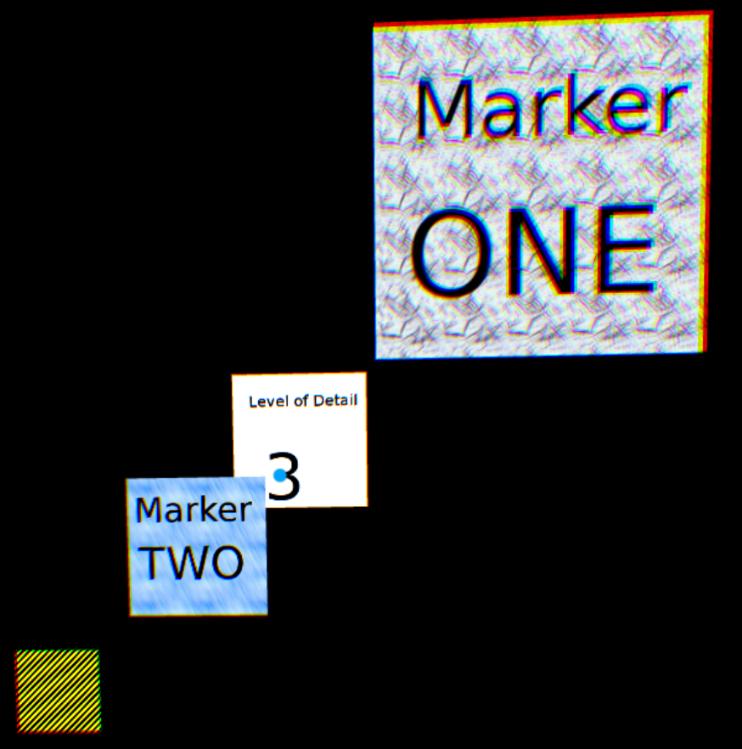

The mesh then animates further back, then quickly comes back to the foreground, going through the three levels-of-detail as it moves forward.

**levelofdetail03.x3d**

Similar to the above demo, however, each of the three planes with the texture maps “Level of Detail 1”, “Level of Detail 2” and “Level of Detail 3” are *Inlined*, meaning, they are each in an external file and use X3D’s <INLINE> tag to include them in the scene. Those external 3 files are: **planemesh1.x3d**, **planemesh2.x3d**, **planemesh3.x3d**.

**levelofdetailusedef01.x3d**

These test with “usedef” in the name perform Level of Detail with the items shared within the scene using X3D’s USE and DEF parameters.

At the bottom of the scene are 3 separate meshes, and each has the same texture map, however, their material colors are different. Each object has a “<Shape DEF=”shapeDog*X*”> where “X” is either 1, 2 or 3. For example, the far left yellow object has a shape node *<shape DEF=”shapeDog1”>*. The objects used in the Level of Detail are defined simply by:

*<LOD range='4 9'>*

*<shape USE="shapeDog1"/>*

*<shape USE="shapeDog2"/>*

*<shape USE="shapeDog3"/>*

*</LOD>*

The first image will show the yellow dog that animates toward “Marker ONE”, pause, and slowly animates behind “Marker ONE” while changing to the next Level-of-Detail item, a magenta dog.

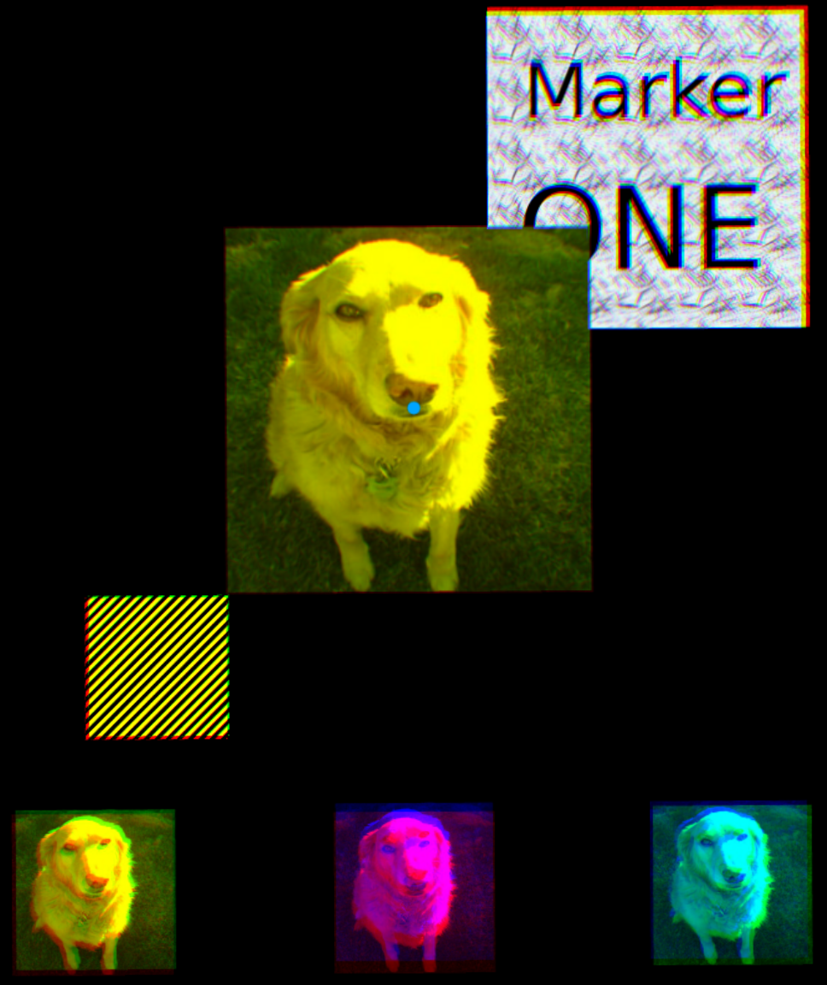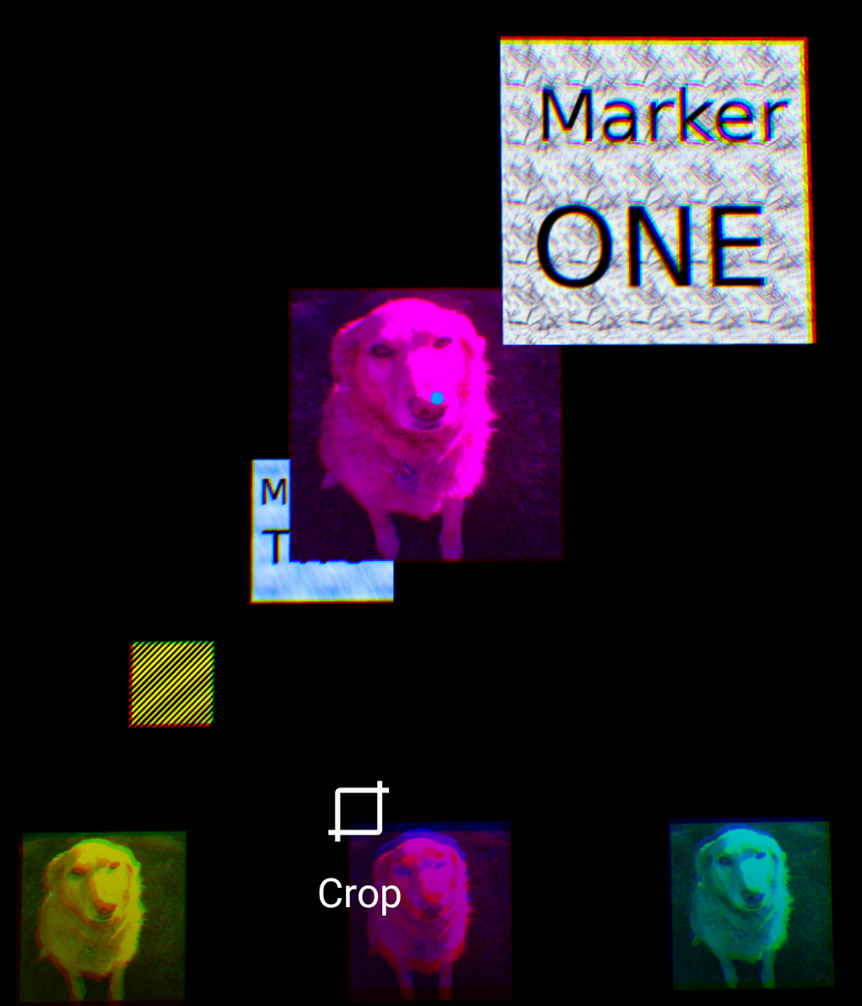

We then animate toward “Marker TWO”, pause, animate slowly behind “Marker TWO” and transition to the blue dog, our 3rd item in the level of detail.

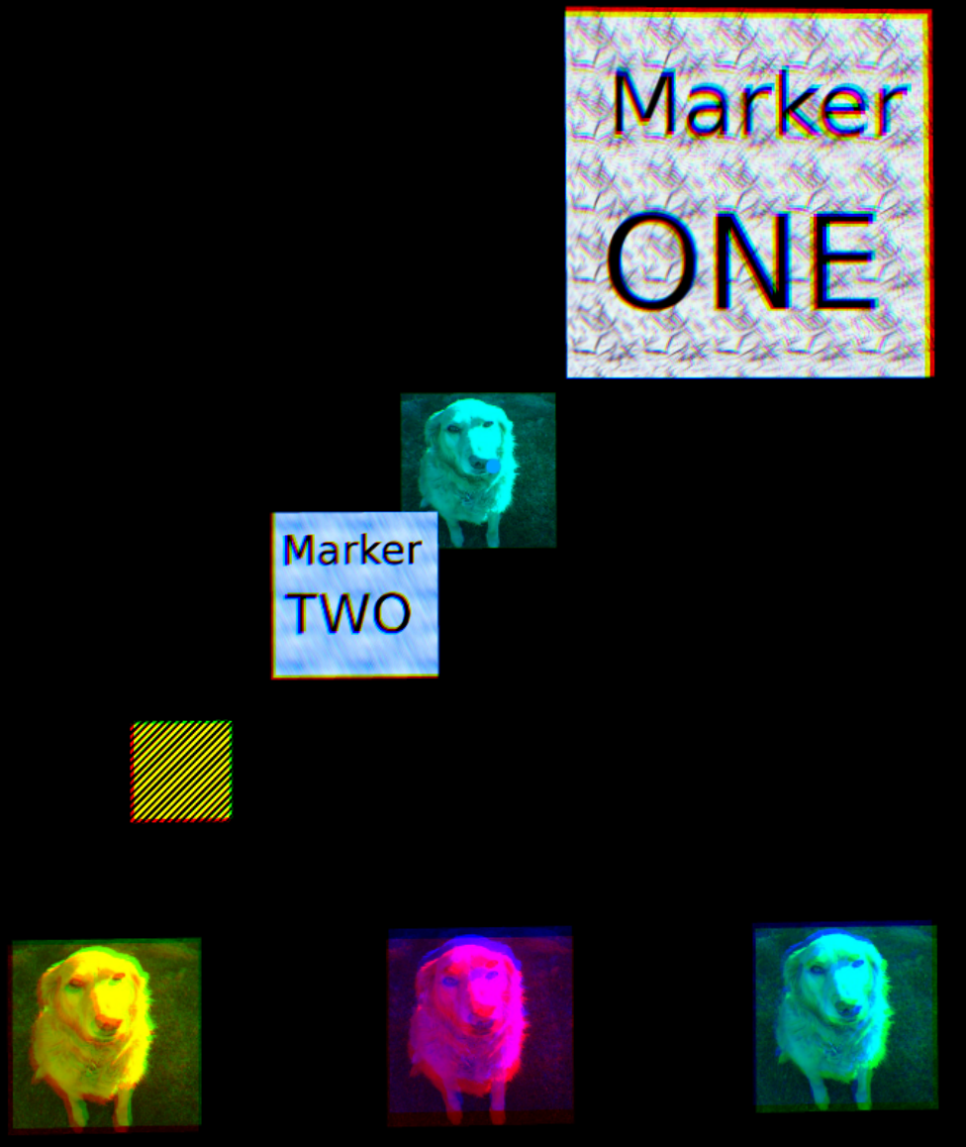

**levelofdetailusedef02.x3d**

Similar to the above demonstration but instead of mesh with “Marker ONE” and “Marker TWO”, it uses text instead.

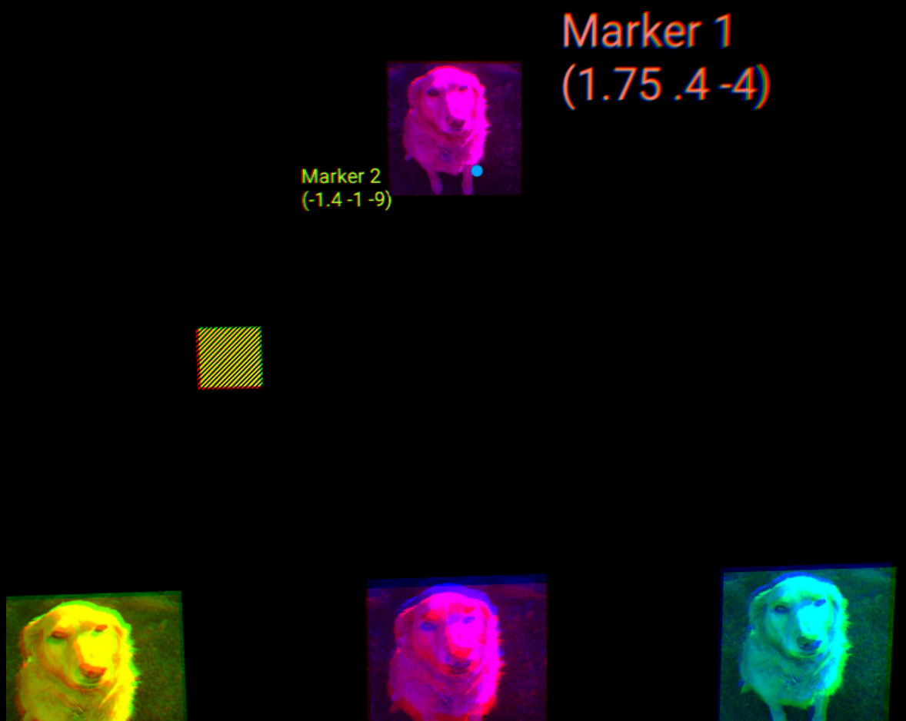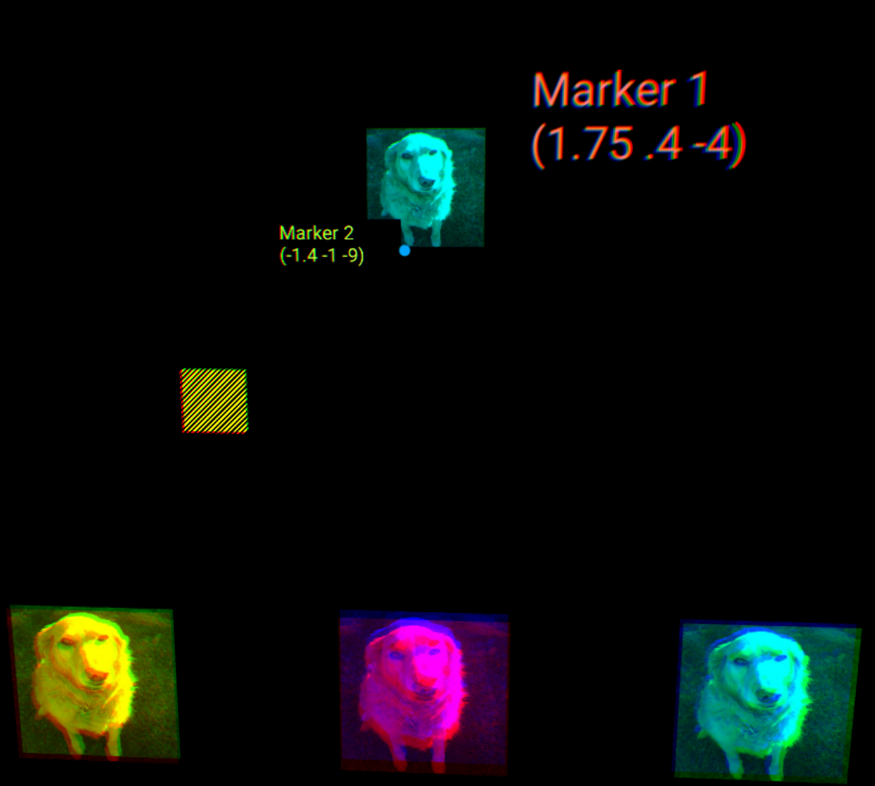

**text-lod-demo.x3d**

A variation of the previous tests, but instead of a textured mesh changing due to level of detail, we use X3D’s *<Text>* node. The text nodes are embedded in external files using X3D’s *<Inline>*, simulating how some developers apply Level of Detail switching to external files.

**<LOD range='4 9'>**

**<Inline url="text-lod-demo1.x3d" />**

**<Inline url="text-lod-demo2.x3d" />**

**<Inline url="text-lod-demo3.x3d" />**

**</LOD>**

